Best dental clinic Ghaziabad

searching for the [best dental clinic Ghaziabad](https://crowndentalcares.com/) then  come to visit our clinic. we are here to offering complete dental treatments. Our clinic, which has also located in Vaishali and Indirapuram. serves a comprehensive wide range of dental services, includes advanced techniques like orthodontics, tooth implants, and cosmetic dentistry. Modern technology is used by our skilled team of dentists to give painless, effective treatment in a comfortab0le environment.

We are dedicated to satisfying your tooth requirements with care and knowledge, whether you need braces, teeth whitening, a smile makeover, or a basic check-up. We put the comfort and care of our patients first, which has made us a reputable name in Ghaziabad for people and families looking for high-quality dental services. Come see us now to discover the value of professional dental treatment for a healthy and bright smile!

**Services at Our Clinic**

**Our clinic offers all kinds of services and constantly study new technology to add new custom services to the list.**

**[Dental Implant Treatment](https://crowndentalcares.com/service/dental-implants-treatment/a)**

**Our dental Clinic provides long-lasting, natural-looking teeth replacement. Enjoy improved chewing, better speech, and enhanced overall dental health with this permanent solution for missing teeth.** **Experience permanent tooth replacement with our expert dental implants, offering comfort, improved .**

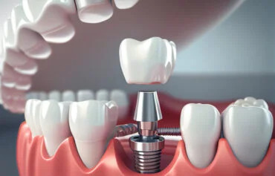

### [Smile makeover](https://crowndentalcares.com/service/teeth-whitening-treatment-teeth-cleaning-centre/)

### joy your smile with our professional Smile Makeover services, including advanced teeth whitening treatment and thorough teeth cleaning. Our expert team specializes in brightening and revitalizing your teeth, giving you a confident, radiant smile. At our Advanced\ teeth cleaning centre, we ensure safe and effective procedures that remove stains, plaque, and discoloration.

### 

### [Scaling and Root planning](https://crowndentalcares.com/service/scaling-and-root-planing/)

### Scaling and root planning are crucial for maintaining gum health and preventing serious dental issues. Our team is dedicated to providing thorough and compassionate care.

### 

## Wisdom Tooth Removal

If wisdom teeth fail to be extracted on time, they may result in pain, infection, or crowding. With sedative choices and detailed post-procedure instructions to ensure an easy recovery, our team is dedicated to providing personalized treatment.