Co-ord Set for Woman: Complete Style & Fabric Guide
By Sugandh Gupta | September 21, 2026
Somewhere along the way, the co-ord set for woman quietly became the easiest way to get dressed without actually thinking about it too much. Two pieces, already matched, already sorted - no standing in front of the closet wondering what goes with what. That's honestly the whole appeal of a good women co-ord set: it takes the decision-making out of getting dressed, and somehow still looks like you put in the effort.
This guide covers pretty much everything worth knowing before buying a co-ord set for woman - the different types, which fabric suits which occasion, how to get the fit right, and a pro tip under every section so you're shopping with some actual direction instead of guessing.

Why a Co-ord Set for Woman Works So Well
The whole idea behind a co-ord set for woman is that the top and bottom are designed together from the start - same fabric behaviour, same weight, same finish. That's different from just pairing two separate pieces and hoping they work. It's why a coordinated set always looks a little more intentional than a random top-and-trouser combination.

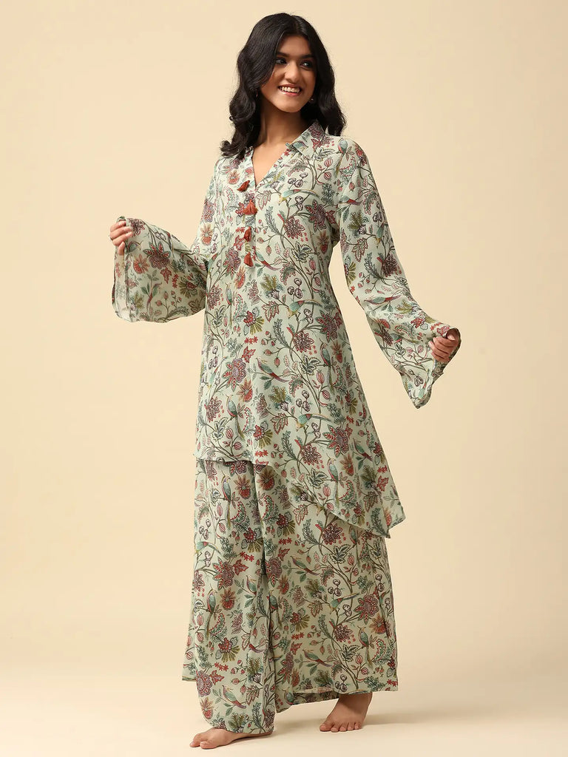
A well-made women co-ord set also tends to outlast trend cycles, since the appeal isn't really about a specific print or moment - it's about the coordination itself, which never really goes out of style.
Pro Tip: Start with one neutral-toned co-ord set before buying anything printed - it pairs easily with jewelry and shoes you already own, so you get more wear out of it sooner.

Types of Co-ord Set for Woman to Know
Not every coordinated set is built for the same moment. Here's how the main categories tend to differ.

Everyday Cotton Co-ord Sets
For daily wear, a cotton or cotton-crepe co-ord set for woman is about as low-effort as it gets.
Breathable, structured without being stiff, and forgiving enough to survive a full day of errands or work-from-home calls without looking rumpled by evening.
Pro Tip: Keep two or three everyday co-ord sets in breathable cotton-crepe - they resist creasing far better than plain cotton through a long day.

Office-Ready Co-ord Sets
A structured cotton-crepe women co-ord set works surprisingly well for office settings that want polish without full formal wear. The fabric's natural crease-resistance keeps the set looking neat from the morning's first meeting through to the evening wrap-up.
Pro Tip: Layer a tailored blazer over an office-ready co-ord set and add pointed-toe heels - it instantly reads more authoritative without changing the outfit itself.

Festive Silk Co-ord Sets
For Diwali, Navratri, or any family celebration, a silk co-ord set for woman brings the richer texture and shine those occasions tend to call for. The built-in drape of silk elevates the coordinated look almost instantly, even with a fairly simple silhouette.
Pro Tip: Pair a festive silk co-ord set with statement earrings and embellished footwear - the set already does most of the work, so accessories just need to complement, not compete.

Georgette Co-ord Set Dress for Sangeet and Social Events
A flowy georgette women co-ord set sits right at the meeting point between traditional and contemporary - fluid in movement, easy on the eye, and dressy enough for sangeet nights, pre-wedding events, or cocktail gatherings without going as formal as a saree or lehenga.
Pro Tip: Keep neck jewelry minimal with a flowy georgette set - the movement of the fabric is already the main visual, so let it lead.

Choosing the Right Fabric for Your Co-ord Set for Woman

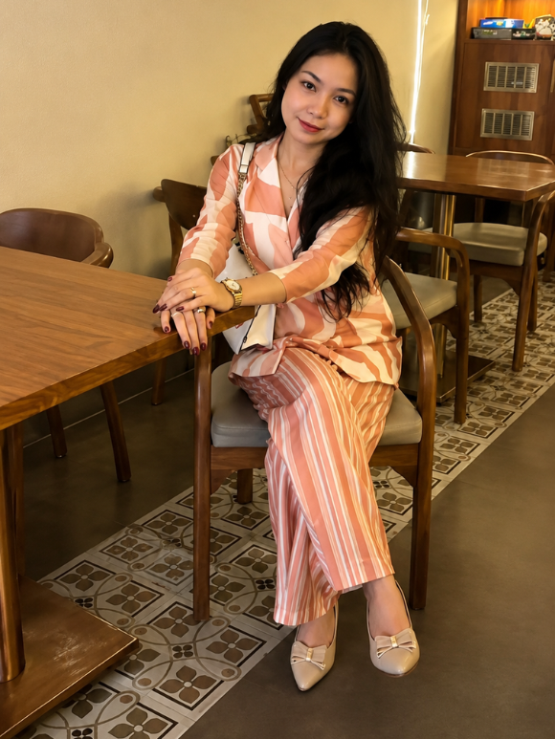
- Fabric decides how a coordinated set actually feels to wear, not just how it photographs.
- Cotton: Breathable and soft, best for everyday wear and warmer climates.
- Cotton-Crepe: Structured yet flowy, resists creasing, ideal for both daily and office wear.
- Silk: Natural sheen and built-in drape, suited to festive and celebratory occasions.
- Georgette: Lightweight and fluid, brings effortless movement to evening and wedding-adjacent events.
Pro Tip: If you can only invest in one silk co-ord set, choose a deep jewel tone like wine or emerald - it holds up equally well in daylight photos and evening lighting.

How to Choose the Right Fit and Size
A good co-ord set for women should skim the body with a structured but comfortable silhouette, rather than clinging tightly. Since cut and proportion can vary between styles, it's worth checking the size chart on every product page rather than assuming your usual size will fit the same way.
- Straight-cut co-ord sets flatter most body types with minimal styling effort.
- Petite frames often suit shorter top lengths paired with slightly higher-waisted bottoms.
- Fuller figures are usually flattered by structured cotton-crepe over very lightweight, clingy fabrics.
Pro Tip: When between two sizes, size up rather than down - a slightly relaxed co-ord set can always be nipped in with a belt, but a tight one just feels restrictive all day.

Styling a Co-ord Set for Woman Across Occasions

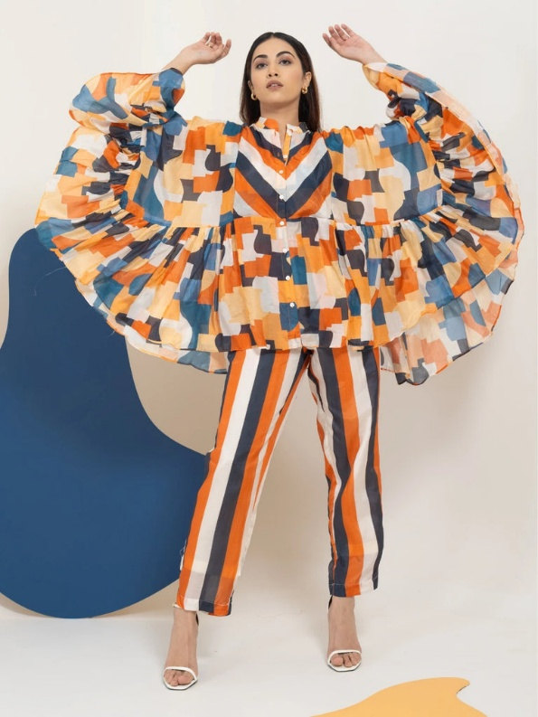
for daytime looks, pair with minimalist jewelry and comfortable flats for easy, unforced elegance.
- For evening functions, switch to statement metallic earrings and embellished heels for a sharper finish.
- The coordinated tops and bottoms can also be styled separately - try the top with solid trousers, or the bottoms with a crisp white shirt.
- Add a structured blazer or jacket over a co-ord set on cooler days without losing the coordinated look underneath.
Pro Tip: Keep one printed co-ord set and one solid one in rotation - the solid set restyles endlessly, while the printed one becomes your reliable go-to for a specific occasion.

Caring for Your Women Coord Set
Since coordinated sets are often made from natural fabrics with finer detailing, a little extra care keeps them looking sharp.
- Dry clean or gently hand-wash cotton-crepe and linen sets in cold water to preserve the structured drape.
- Dry in the shade rather than direct sunlight to protect the depth of the color.
- Iron on low to medium heat while the fabric is still slightly damp for a crisp, finished look.
Pro Tip: Store silk and embellished co-ord sets in breathable muslin bags rather than plastic covers - it protects both the fabric sheen and any hand-applied detailing.

Frequently Asked Questions

What makes a co-ord set for woman different from a regular two-piece outfit?
A true co-ord set is designed with the top and bottom together from the start, sharing fabric weight, drape, and finishing - not just two separate pieces paired after the fact.

Can a women co-ord set be styled for both office and festive occasions?
Yes - a versatile cotton-crepe set can go from office-ready with minimal jewelry to festive-evening-ready with a statement dupatta or metallic accessories.

Which fabric is best for a first-time co-ord set buyer?
Cotton or cotton-crepe is the easiest starting point - breathable, low-maintenance, and versatile enough for both daily wear and light festive occasions.

How many co-ord sets should I own?
A practical starting point is two to three everyday cotton sets, one office-ready set, and one festive silk or georgette set for celebrations.

