Indo Westerns Collection for Women: What to Buy & Why
By Sugandh Gupta | September 21, 2026
Building an Indo Westerns Collection for Women sounds simple until you're actually standing in front of a rack full of fusion pieces, unsure which ones will earn their keep and which will sit unworn after one event. The best Indo western dress for women isn't necessarily the most dramatic one it's the one you'll reach for again, across more than one kind of occasion.
Instead of repeating the usual breakdown of styles and fabrics, this guide focuses on how to actually shop smart by occasion, by common mistakes to avoid, by how to accessorize, and by body type with a pro tip under every section along the way.

What Actually Counts as an Indo Western Dress for Women
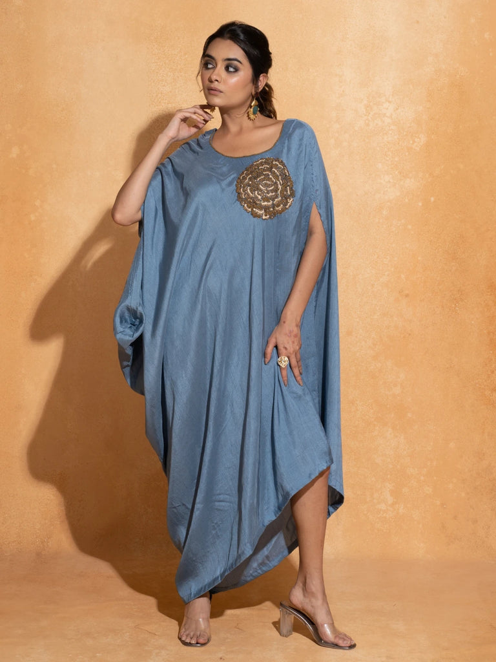
Before building an Indo Westerns Collection for Women, it helps to know what separates fusion wear from either pure ethnic or pure western clothing. A genuine best Indo western dress for women combines at least one clearly Indian design element embroidery, a traditional colour story, or a familiar silhouette like the kurta or lehenga with a modern structural choice, such as a pre-draped skirt, a structured cape, or a western-style cut.
Pro Tip: If a piece could pass as purely western or purely traditional on its own, it probably isn't true fusion wear look for that clear blend of both before buying.

Building Your Indo Westerns Collection for Women by Occasion
Rather than buying whatever looks good on a mannequin, it helps to map your purchases to where you'll actually wear them.

Work and Everyday Fusion Wear
For office days, a fusion kurta set with a clean neckline and minimal embellishment is usually the safest pick in an Indo Westerns Collection for Women polished enough for meetings, distinct enough to still feel like fusion rather than plain formal wear.
Pro Tip: Stick to solid colours or subtle prints for office-appropriate fusion pieces bold embellishment tends to read as too festive for a workday.

Date Nights and Casual Outings
A shorter fusion dress or an asymmetric-hem kurta set works well here relaxed enough for a casual dinner, still distinct enough to stand out among plain western outfits.
Pro Tip: Pair a casual fusion dress with simple gold jewelry rather than heavy Indian pieces it keeps the overall look balanced instead of overdressed.

Festive and Wedding-Adjacent Events
This is where the best Indo western dress for women tends to get more dramatic fusion lehengas, structured gowns, and sangeet-ready pieces with fluid fabric and surface embroidery all belong in this category.
Pro Tip: Save your most elaborate fusion piece for one key wedding function rather than repeating it across the whole wedding season.

Destination and Resort Occasions
Flowy kaftans with Indian print or embroidery work surprisingly well as fusion pieces for destination weddings and resort settings light enough for travel, still detailed enough to belong in an Indo Westerns Collection for Women rather than reading as plain beachwear.
Pro Tip: Choose a kaftan with a single strong print or embroidery placement rather than an all-over pattern it photographs better in bright, outdoor destination lighting.

Colour and Print Stories Worth Knowing
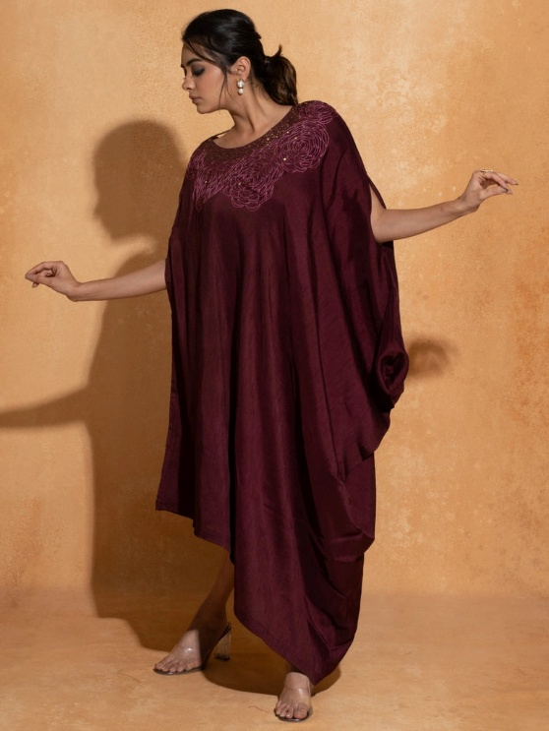
Fusion wear tends to lean into rich, traditional colour families think warm oranges, deep reds, golds, and jewel tones layered against cleaner, more contemporary silhouettes. Knowing which colour families work for which occasion makes shopping considerably faster.
- Warm tones (orange, gold, yellow) suit daytime festive occasions like haldi.
- Deep jewel tones (wine, emerald, navy) suit evening functions and receptions.
- Neutral and pastel fusion pieces work best for office or casual daytime wear.
Pro Tip: Buy at least one neutral-toned fusion piece before investing in bold prints neutrals restyle across more occasions and hold their value in your wardrobe longer.

Common Mistakes to Avoid When Buying Indo Western Wear
- Buying only heavily embellished pieces, leaving nothing simple enough for daytime or office wear.
- Ignoring the size chart on structured pieces, since fusion silhouettes often fit differently than standard ethnic wear.
- Choosing a piece purely for how it looks in a photo, without checking whether the fabric suits your climate or the event's duration.
- Overlooking care instructions on delicate fusion pieces, which often combine structural tailoring with hand embellishment.
Pro Tip: Before buying, ask yourself if you can name at least two occasions you'd wear the piece to if you can't, it's probably not a smart addition to your Indo Westerns Collection for Women.

Accessorizing Your Best Indo Western Dress for Women
- Pair heavily embroidered fusion pieces with minimal, metallic accessories to avoid visual overload.
- Use statement Polki or Kundan jewelry with simpler, solid-colour fusion gowns for a more dramatic finish.
- Swap heels for embellished flats at sangeet or haldi events where you'll be dancing for hours.
Pro Tip: When in doubt, let the outfit lead if the fusion piece already has strong embroidery or print, keep jewelry down to one statement item rather than several.

Body Type Guidance for Fusion Silhouettes
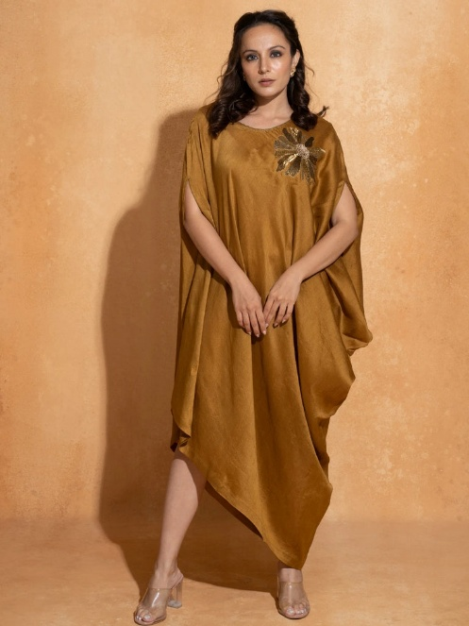
- Structured bodices and fitted fusion gowns flatter hourglass and pear body types especially well.
- Flowy kaftans and A-line fusion kurta sets are more forgiving across most body types.
- Petite frames often suit shorter fusion hemlines paired with straight-cut bottoms rather than heavily layered skirts.
Pro Tip: If you're unsure how a structured fusion piece will fit, check whether the brand offers pre-stitched or pre-draped options they tend to be more forgiving than fully custom draping.

Building a Small Indo Western Capsule Wardrobe
You don't need a dozen fusion pieces to feel prepared for every event. A well-planned Indo Westerns Collection for Women of around four to five pieces one office-ready kurta set, one casual fusion dress, one festive lehenga or gown, and one destination-ready kaftan covers most of the year's occasions without repetition.
Pro Tip: Choose your capsule pieces in colours that can be mixed with jewelry and footwear you already own it stretches your existing wardrobe further.

Frequently Asked Questions

How is an Indo Westerns Collection for Women different from a regular ethnic wardrobe?
An Indo Westerns Collection for Women specifically blends Indian design elements with modern structural cuts, while a regular ethnic wardrobe stays closer to traditional silhouettes throughout.

What's the most versatile piece to start with?
A neutral-toned fusion kurta set is usually the most versatile starting piece, since it works for both office wear and casual festive occasions.

Can Indo western wear be worn to a formal wedding?
Yes fusion lehengas and structured gowns are increasingly common at receptions and cocktail-style wedding events where a fully traditional look isn't required.

How do I know if a fusion piece is worth buying?
If you can identify at least two different occasions where you'd realistically wear it, it's likely a smart addition rather than a one-time purchase.

