Mehendi & Haldi Outfits: Best Pre-Wedding Looks 2025

Mehendi and haldi are kinda two of the most relaxed, joyful wedding days, lots of turmeric , music , and those long hours of henna application, and honestly they really do deserve their own wardrobe plan… not just a random repeat thing. When you choose the right Mehendi & Haldi Outfits, it isnt only about colour, it is more like picking pieces you can actually sit, dance, and move without feeling stuck or fussy during the whole playful celebration. This guide goes through real haldi mehndi outfits for girls, and it is organised by silhouette, colour, and fabric too. Everything here is styled for those two functions, so you get the right feel, from the first ritual moment to the last photo.

At World of Sugandh, our pre-wedding wardrobe is built around that exact vibe, relaxed but festive, and the ideas below are pulled from the same collection of Mehendi & Haldi Outfits.

Why Mehendi and Haldi Need a Different Kind of Outfit

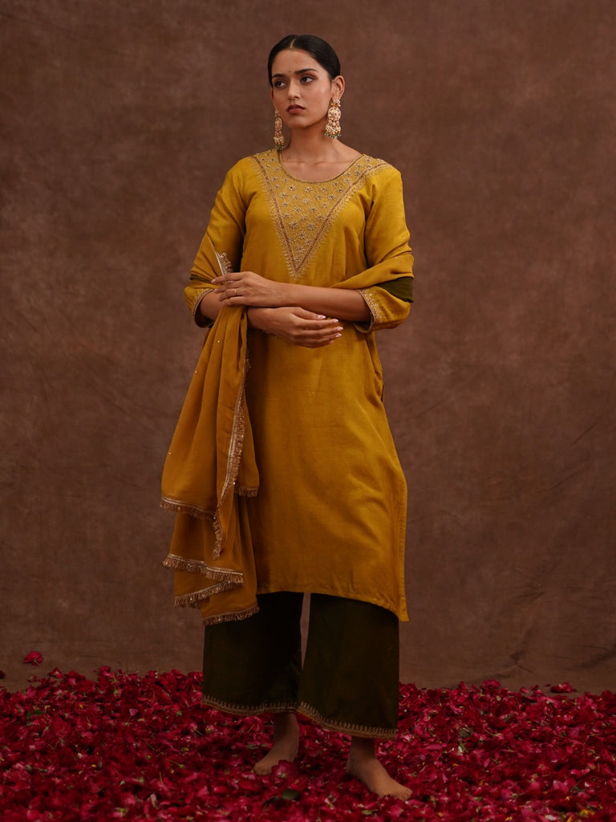

Unlike the main wedding ceremony, mehendi and haldi are more informal, colourful, and very physically active , so Mehendi & Haldi Outfits have to put comfort first, not just festive looks.

Haldi Calls for Ease of Movement

Haldi means you’re sitting through turmeric rituals, with people around you constantly, so haldi mehndi outfits for girls should have practical necklines and sleeves that do not get in the way of the ceremony. like… easy to handle, easy to breathe in.

Mehendi Calls for a Touch More Polish

Mehendi evenings are usually dressed up more than haldi mornings, so Mehendi & Haldi Outfits for this part often lean into richer colour , and a little more embellishment too. Still, though , they should stay easy to move.

Pro Tip: Try separate outfits for haldi and mehendi, because the mood, lighting , and comfort needs are genuinely different, even if you’re the same person wearing them.

Haldi Outfit Ideas: Yellow, Mustard and Green Picks

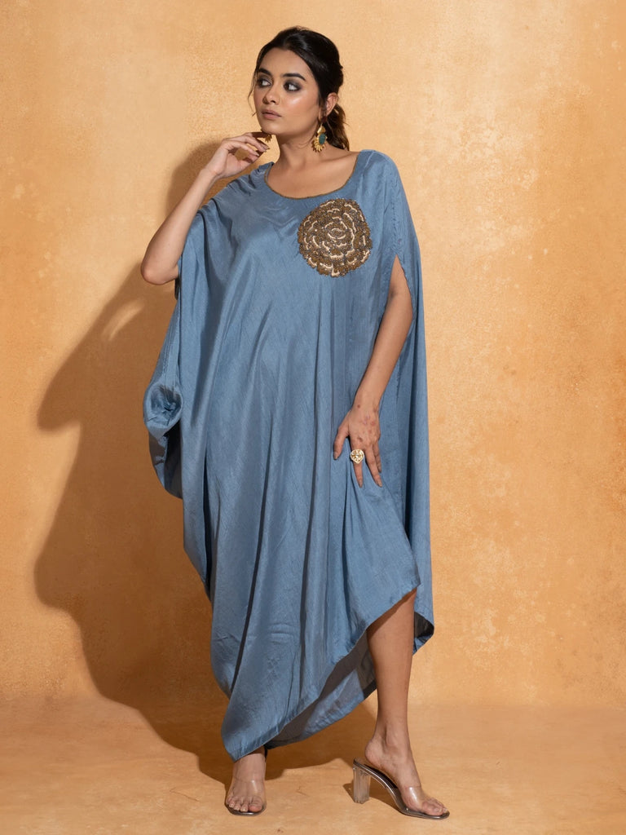

Yellow and mustard stay the classic vibes for haldi mehndi outfits for girls, and this wardrobe has a bunch of pieces that are kinda built around that colour story.

Amaltas Yellow Silk Kurta Set for a Bright Haldi Look

The Amaltas Yellow Silk Kurta Set is a warm, sunny pick for haldi mornings, silk keeps that drape smooth and the yellow tone photographs beautifully in daylight, so it ends up being one of the cheerfullest Mehendi & Haldi Outfits in the collection.

Haldi Gulab Kurta Set for a Softer Yellow

If you want the same family but gentler , the Haldi Gulab Kurta Set gives a softer yellow shade. It still feels festive, just not too bold, and it is a comfortable choice among haldi mehndi outfits for girls who join morning rituals.

Mustard Amber Gown for a Modern Silhouette

Want something slightly different from a kurta set? The Mustard Amber Gown gives you the same warm mustard tone, but in a flowing, modern silhouette. It’s a solid option for Mehendi & Haldi Outfits with a contemporary edge.

Pro Tip: Yellow and mustard tones really shine in natural outdoor daylight, and that is exactly where most haldi functions happen.

Mehendi Evening Picks: Kaftans and Anarkali Sets

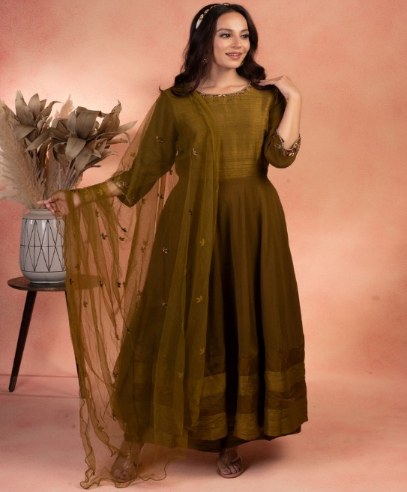

Mehendi evenings usually ask for something a little richer, and kaftans, along with Anarkali silhouettes, work especially well among haldi mehndi outfits for girls who want comfort with a festive finish.

Classic Green Anarkali Set for Traditional Elegance

The Classic Green Anarkali Set brings a rich green tone in a flowing silhouette that moves well through a mehendi evening filled with music and dancing. It is a strong choice among Mehendi & Haldi Outfits made for movement.

Aqua Blue Single Rose Kaftan for Relaxed Comfort

The Aqua Blue Single Rose Kaftan is a breezy, relaxed pick, with just one floral motif. If you want haldi mehndi outfits for girls that feel effortless, rather than heavily structured, this one fits.

Bird Leaf Kaftan for Soft Floral Detailing

The Bird Leaf Kaftan has gentle floral embroidery in soft mauve and beige tones. It is a quieter, but still elegant option among Mehendi & Haldi Outfits, especially for smaller , more intimate gatherings.

Pro Tip: Go for a kaftan silhouette if your mehendi function has a lot of standing and mingling, because it moves easily without needing constant adjusting.

Rich Colour Picks for a Bolder Mehendi Look

Not every mehendi outfit has to be pastel or yellow. Some pieces in this wardrobe lean into deeper, richer colour, if you want your haldi mehndi outfits for girls to actually stand out.

Daisy Lime Green Kurta Set for a Fresh Statement

The Daisy Lime Green Kurta Set mixes a vibrant lime shade with gold detailing on the sleeves. It’s a lively option among Mehendi & Haldi Outfits if you want your colour to be the main focus point.

Lilac Cut Embroidery Kaftan for a Jewel-Toned Look

The Lilac Cut Embroidery Kaftan brings a rich purple tone, plus detailed cutwork embroidery. This is a good choice among haldi mehndi outfits for girls who prefer jewel tones over the usual yellow and green palette.

Gulmohar Kurta Set for Deep Wine Richness

For a warmer, deeper mood, the Gulmohar Kurta Set in a rich wine shade works beautifully for an evening mehendi function. It also shows that Mehendi & Haldi Outfits dont always have to sit on the brighter end of the colour wheel.

Pro Tip: If you are attending both haldi and mehendi, pick one bright colour for the day and one deeper jewel tone for the evening. That way your looks stay distinct, not overlapping.

Fabric Guide for Haldi Mehndi Outfits for Girls

Picking a fabric is kinda a big deal, because it affects how at ease an outfit feels during a long, busy function. This collection has a pretty solid mix that works across the whole event, you know

Cotton and Georgette for Daytime Haldi Functions

For daytime haldi mehndi, cotton plus georgette is usually the most sensible combo. Breathable cotton keeps things comfy, while lightweight georgette feels easy when you are moving around a lot, plus it tends to handle turmeric rituals and outdoor hours fairly well

Silk for Evening Mehendi Functions

Then for evening mehendi functions, something with a richer feel helps, like the Gulmitti Kurta Set. It’s made with silk and comes with a matching dupatta, so the drape looks more dressed up, and it gives that little extra glow when the lights and vibe are more glamorous, and yes, it pairs nicely with Mehendi & Haldi Outfits overall

Pro Tip: For haldi, try to dodge heavily embellished or stiff fabrics. Turmeric paste plus constant movement needs softer, breathable material, period

How to Choose Mehendi & Haldi Outfits Based on Your Role

Honestly the “right” haldi mehndi outfits for girls depends on who you are in the celebration, like bride, close family, or a guest coming in for just one part

For the Bride

Brides usually go for a bit more of a statement. Something like the Mrigja Chand Kurta Set works well, it looks standout, yet still gives room to move freely so you can stay in the centre of it all

For Sisters and Close Family

Close family, especially the bride’s sisters, often coordinate their Mehendi & Haldi Outfits with the bride’s colour theme. But they still manage to keep their own individual style too, not everything has to be identical

For Guests

Guests who attend only one function should lean toward a simple kurta set or a kaftan. These are way more comfortable than pieces that are heavily embellished, since those can feel more like a bridal wardrobe moment

Pro Tip: If you are a guest, it helps to ask about the colour theme earlier. Many families coordinate haldi mehndi outfits for girls across the bridal party, for easier matching in photos

Common Mistakes to Avoid When Picking Mehendi & Haldi Outfits

● Choosing too much embellishment or a stiff fabric for haldi, when turmeric and movement really need something gentler

● Wearing the exact same outfit for both haldi and mehendi, instead of planning two different vibes, ya know

● Forgetting most haldi functions happen outdoors in daytime, and picking fabric colour like it’s a night event

● Skipping the size chart. Fit decides how flowy silhouettes like kaftans and Anarkali sets actually move, so don’t guess

Pro Tip: Try your whole outfit once, including the dupatta if you’re wearing one. Do it before the function, because tiny adjustments feel way easier when you have time, instead of right at the last minute

Frequently Asked Questions

What colours work best for haldi mehndi outfits for girls?

Yellow, mustard, and green remain the most traditional choices for haldi, while mehendi functions allow for richer greens, purples, and warm oranges.

Can I wear the same outfit for both haldi and mehendi?

It is possible, but most people prefer separate Mehendi & Haldi Outfits since the two functions differ in mood, lighting, and how much movement is involved.

Which fabric is most comfortable for a haldi function?

Breathable cotton and lightweight georgette work best for haldi, since they handle turmeric application and long outdoor hours comfortably.

Are kaftans a good option for mehendi functions?

Yes, kaftans are a popular pick among haldi mehndi outfits for girls who want comfort and movement without giving up on festive colour and embroidery.

Whatever function you are dressing for, the goal with Mehendi & Haldi Outfits stays the same, pick pieces that let you sit, dance, and celebrate freely while still feeling festive and photo-ready through every ritual.

