Dresses for Wedding Day: Best Outfit Ideas for 2025
A wedding day is rarely just one thing, it is more like a whole chain of mehendi mornings , sangeet nights, and reception dinners all crammed close together, and each bit kinda asks for slightly different dresses for wedding day dressing. Getting it right matters a lot, because the outfit you choose kinda decides how comfy, photo ready, and self assured you feel through every ritual. This guide goes through real outfits for wedding day dressing, kind of mapped by silhouette, color, and fabric, so you know what you should be looking for before you even start shopping.
At World of Sugandh , our handcrafted pieces are made with these long, multi-function wedding days in mind, and the ideas below come straight from our own dress wardrobe of wedding day occasions.

Why the Wedding Day Wardrobe Needs More Than One Outfit
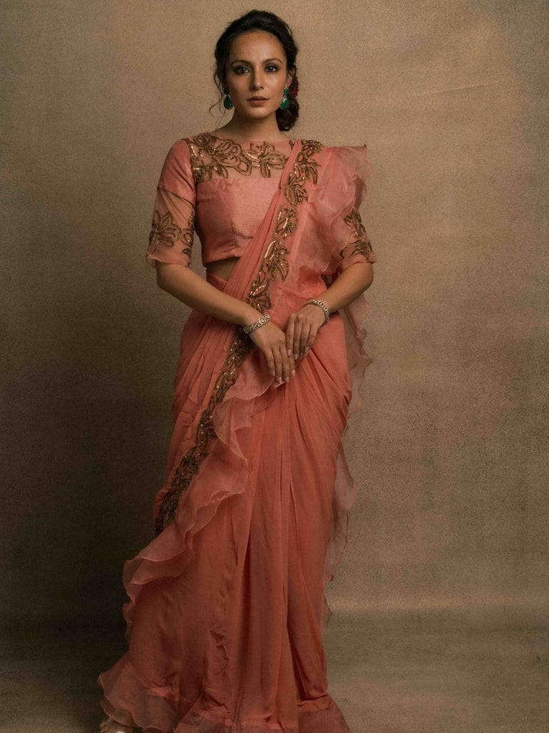

Most Indian weddings aren’t a single event, they stretch across mornings and nights, sometimes over a few days too. Because of this, outfits for wedding day dressing usually work best like a tiny wardrobe, not one single showstopper piece, a lighter outfit for daytime rituals and a richer one for the evening.

Daytime Functions Need Ease of Movement
Haldi and mehendi mornings involve lots of sitting, standing, and moving around guests, so dresses for wedding day mornings should focus on breathable fabric and a relaxed fit, over heavy embellishment that can feel too much.

Evening Functions Call for Richer Drama
Sangeet and reception nights are where outfits for wedding day dressing can lean into deeper shades, more luxurious fabric, and detailed embroidery, since the setup and lighting are literally made for that kind of impact.

Pro Tip: Think about your wedding wardrobe as a set, not separate random pieces, a breathable outfit for daytime and one statement outfit for evening covers almost every moment, pretty smoothly.
Kurta Sets for Wedding Day: Comfort Meets Elegance
Kurta sets stay one of the easiest dresses for wedding day choices, because they balance comfort with a crisp, elegant silhouette that works for both daytime and evening functions.
Amaltas Yellow Silk Kurta Set for Haldi Mornings
The Amaltas Yellow Silk Kurta Set is a bright, sunny kind of pick that suits haldi functions, the silk base keeps everything draped easy , while that yellow tone shows up beautifully in daylight, so it becomes one of the happiest outfits for wedding day mornings.
Haldi Gulab Kurta Set for a Softer Daytime Look
If you want something gentler, the Haldi Gulab Kurta Set gives a softer yellow shade that still reads festive without looking too loud, a comfortable choice among dresses for wedding day functions that happen earlier in the day.

Kumkum Silk Kurta Set for Evening Depth
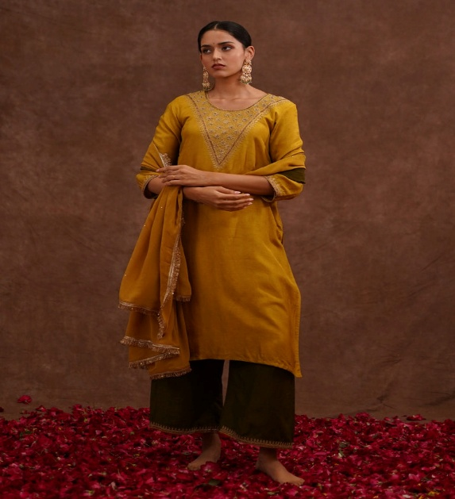
When the function shifts into evening, the Kumkum Silk Kurta Set, with its deeper brown and black tones, brings a more grounded, celebratory richness, kind of proving that outfits for wedding day evenings do not always have to be bright colour to feel standout.
Pro Tip: Pick one kurta set in a lighter tone for daytime rituals, and one in a deeper shade for evening functions, that one idea alone basically covers the majority of your wedding wardrobe.

Anarkali and Ghaghra Sets for a Regal Wedding Day Look
For events that want more volume and visible grandeur, anarkali and ghaghra silhouettes are among the most flattering dresses for wedding day choices in this collection.
Neelara Kurta Set for Traditional Black and Gold Glamour
The Neelara Kurta Set mixes a black base with intricate gold embroidery work, giving that regal, traditional finish that fits reception nights, and also other dresses for wedding day evenings that need a statement mood.
Seawood Embroidered Ghaghra Set for a Bold Green Statement
The Seawood Embroidered Ghaghra Set grabs attention in a rich green shade with detailed embroidery, a great option for anyone who wants their dresses for wedding day look to feel noticeably different from the usual red and maroon options.
Pro Tip: A ghaghra or Anarkali silhouette photographs especially well during the phera and mandap seating, since the flare falls beautifully whether you’re standing or seated too.

Sharara and Silk Sets for Festive Movement

Functions, like sangeet, are where flared shapes and rich silk kinda just steal the whole moment, so for wedding day options it helps to go for something that actually moves, not only looks perfect in one pose.

Ruby Radiance Sharara Set for a Festive Red Look

The Ruby Radiance Sharara Set does that classic wedding red thing with a flared silhouette that glides through dance, laughter, and all the celebration energy , it is a solid choice when you are deciding between dresses for wedding day sangeet functions.

Rangratna Lilac Mauve Silk Kurta Set for a Softer Palette

And if red feels a bit too loud for your taste, the Rangratna Lilac Mauve Silk Kurta Set gives you a gentler purple mood, plus that same festive silk richness , this is proof that outfits for wedding day dressing do not need to stick to one color story only.

Pro Tip: If you plan to dance through the sangeet, choose a silhouette with a flared skirt or palazzo, instead of something tight, comfort during movement matters just as much as how it looks standing still.

Colour Guide for Choosing Outfits for Wedding Day Functions

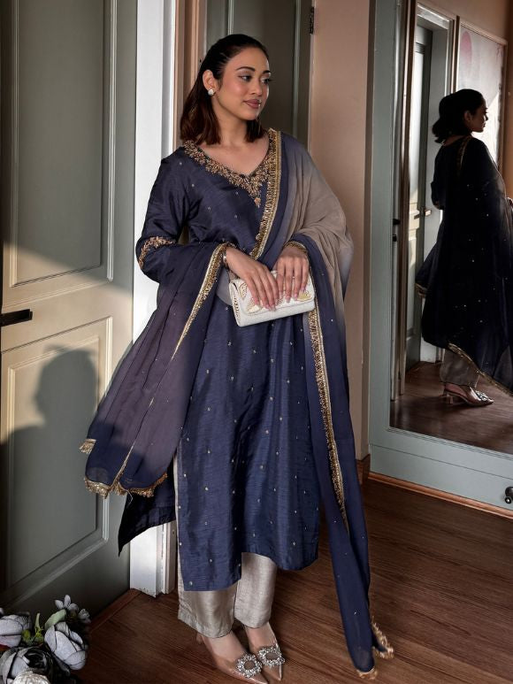

Colour is one of those super personal calls in dresses for wedding day dressing, and this line covers a broad spread , from deeper reds to soft pastels that feel airy even in photos

Reds, Maroons and Wine Tones for the Main Ceremony

Options like the Ruhani Red Silk Kurta Set and the Gulmohar Kurta Set in a wine-toned shade are the reliable picks for close family attending the main ceremony, these tones look rich in camera and suit lots of skin tones, honestly.

Oranges, Pinks and Pastels for Daytime Warmth

If you are dressing for daytime events, warmer shades such as the Surkhiya Orange Kurta Set, or rose-pink vibes like the Gulchaand Kurta Set bring a softer energy, great for mehendi and other outfits for wedding day functions that happen before evening.

Pro Tip: If you are going to attend several functions, keep one deeper colour and one lighter shade, so your dresses for wedding day looks do not end up repeating across the week.

Fabric Focus: Why Silk Leads Wedding Day Dressing

Almost every standout piece here, from the Neelvara Kurta Set to the Gulmitti Kurta Set, is made in silk, and there is a reason for that, you can feel it too.

Silk's Natural Sheen and Drape

Silk catches light in a way cotton or linen simply cannot, which is why so many outfits for wedding day evenings, especially reception and sangeet pieces, are built on a silk base.

Pairing Silk with a Dupatta for Added Grace

Pieces like the Gulmitti Kurta Set also include a matching dupatta, adding another layer of motion and elegance , that small detail really lifts dresses for wedding day looks in photographs.

Pro Tip: Silk creases easily, so hang your outfit the night before rather than folding it, this keeps the drape looking fresh during long photo sessions and busy rounds.

How to Choose Dresses for Wedding Day Based on Your Role

The best pick among outfits for wedding day options depends on whether you are close family, a friend, or a guest who is attending just one event.

For Close Family Members

Close family can lean into richer pieces like the Rangdaari Kurta Set or the Mrigja Chand Kurta Set, both have festive detailing that works nicely for photos, especially when you are standing beside the couple.

For Guests Attending a Single Function

Guests going to just one function usually do better with a simpler, comfortable kurta set, rather than heavier wedding day dresses that feel like too much for long hours.

Pro Tip: As a guest, check with the hosts about the function’s dress code in advance, many outfits for wedding day celebrations now follow colour themes per event.

Common Mistakes to Avoid When Picking Outfits for Wedding Day

● Buying only one heavy outfit and expecting it to work for every single function across the wedding.

● Ignoring fabric weight for daytime dresses for wedding day functions, especially when you will be outside for hours.

● Skipping the size chart, since fit changes how flared silhouettes like sharara and ghaghra sets actually move.

● Choosing colour without seeing how it matches the couple’s own outfit shades for that function.

Pro Tip: Try your full outfit, including dupatta and footwear, at least once before the wedding week, small tweaks are far easier early on rather than waiting.

Frequently Asked Questions

Which fabric works best for dresses for wedding day evening functions?

Silk and silk blends are the most popular choice, since they hold embroidery well and catch light beautifully under evening lighting.

How many outfits do I need for a multi-day wedding?

Most people plan for at least two, one lighter set for daytime functions and one richer piece for evening events, though this depends on how many functions you are attending.

Are bright colours like yellow and orange suitable for daytime functions?

Yes, shades like the Amaltas Yellow Silk Kurta Set or the Surkhiya Orange Kurta Set work particularly well for daytime rituals like haldi and mehendi.

Can I wear the same silhouette for both daytime and evening events?

You can, but choosing a lighter colour and fabric for the day and a richer, deeper tone for the evening usually feels more appropriate across different outfits for wedding day functions.

Whatever function you are dressing for, the goal with dresses for wedding day shopping stays the same, pick pieces that let you move, sit, and celebrate comfortably while still looking every bit as festive as the occasion deserves.

