Handcrafted Kurta Sets for Women : Ethnic Style Guide
By Sugandh Gupta | October 16, 2026

There’s this kind of quiet difference between a kurta set that looks embroidered , and one that has actually been done by hand. Far away , sure, they can look the same, like really similar, but up close you notice little stuff where the thread sits, how a bead catches light, and even how the fabric drops after a year, not just after the first wash. And thats basically why handcrafted kurta sets for women still have loyal fans, while mass produced stuff… usually just can’t match it, you know
Shopping for an ethnic kurta set can feel crowded. Cotton or silk, resham or zardozi, with a dupatta , or skipping it, bright red or something softer , all of that can become one big confusing pile. This guide kinda skips the usual “just choose what suits you” type lines, and goes to the part most articles avoid: how handwork is actually made, how to recognise it fast, what it should realistically cost, and how to pick pieces that actually justify the money you pay
Each section ends with a pro tip, so you can keep one practical idea with you at a time, whether you’re buying your first embroidered set, or you are adding to a collection you already love

What Makes Handcrafted Kurta Sets for Women Different
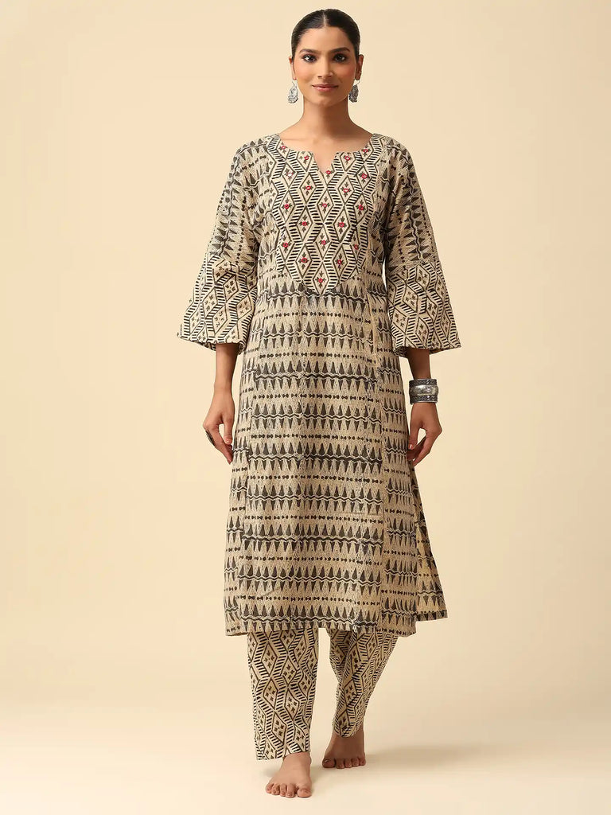
A handcrafted piece is basically defined by where the human skill enters the process. In handcrafted kurta sets for women, artisans place thread, beads, and metallic details by hand, they decide how dense or breathable the pattern should be, and they finish the surface so it lies flat and stays comfortable against the skin. Machines can copy a pattern, but they struggle a lot to copy judgement
And that shows up for wearing too, not only looks. Hand applied embroidery tends to follow the fabric’s own natural movement, so the garment drapes better and feels less stiff. Also every piece ends up with tiny variations, and that’s not really a flaw—its the charm
Pro Tip: Treat small irregularities, like uneven spacing or slight thread tension, as a positive sign, not something to fear. If the repeats look perfectly identical across the whole kurta set, that’s often pointing toward machine work

How to Spot Genuine Handwork in Hand Embroidered Kurta Sets for Woman
If you are buying hand embroidered kurta sets for woman online, you can’t feel the fabric yourself, so you need other clues. With a bit of patience, a few checks help separate real craft from imitation
● Back of the embroidery: Hand work usually looks neat, but slightly different on the reverse. Machine work usually feels uniformly dense and kinda mechanical
● Pattern placement: Handwork is planned around the kurta itself, motifs are adjusted for neckline, sleeve, and hem. Machine patterns often repeat identically no matter the cut
● Close-up photography: If a brand truly believes in its handwork, they show macro images of thread texture, beads, and stitches. No close-ups is a warning sign
● Description language: Specific names like resham, zardozi, beadwork, and hand-finished tell you way more than “embroidered look” style phrases
● Price logic: Handwork takes hours. If the price is extremely low but the embellishment looks heavy, it deserves a second look
Pro Tip: For handcrafted kurta sets for women, zoom into the product photos until you can spot individual stitches. If the images are too low-resolution to judge, ask the seller for a close-up before you order

Why Fabric Choice Decides How Long Handwork Stays
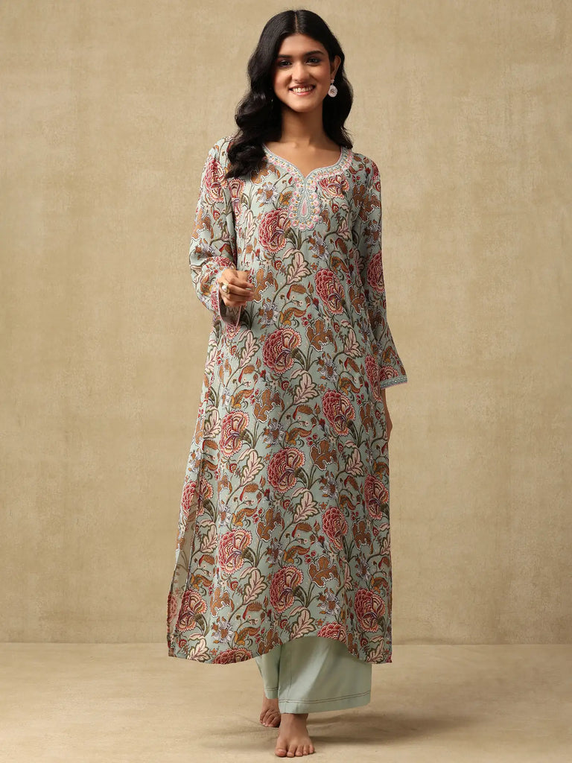
Dense embroidery is kinda heavy, if the base fabric is too thin then the whole weight of the handwork pulls on it and you’ll start seeing puckering, and honestly the garment can lose its shape after a few wears. so, that’s why the best Handcrafted kurta sets for women usually mix rich embellishment with fabrics that have enough body to hold it up.
● Cotton-crepe: structured but still breathable, it keeps embroidery set in place and helps resist creasing, so it works well for pieces you want to repeat a lot.
● Silk: naturally strong and shiny, silk supports dense zardozi and beadwork easily, and it feels at home at festive plus wedding type evenings.
● Georgette: light, airy, it’s made for delicate surface work and it gives dupattas and flared bottoms that nice movement.
● Cotton and cotton-silk blends: comfy and flexible, these are a solid route for embroidery that’s moderate in density and meant for regular festive wear.
Pro Tip: For handcrafted kurta sets for women, when the embroidery is heavier then the base fabric needs to be sturdier too. If a super light fabric ends up carrying super dense handwork, expect sagging over time.

Latest Kurta Set for Woman: What to Look For This Season, but not only
Trying to find the latest kurta set for woman can pull you toward trends that fade fast. A better move is to separate longer-lasting design ideas from the quick buzz, so what you buy still feels right next month… not just right now.
Silhouettes that keep coming back
Straight kurtas with palazzos, relaxed A-line cuts, flared Anarkali shapes, and Angarkha-style wraps seem to show up again and again. This is mostly because they flatter many body types, and they also play nicely with different dupatta styles and shoes, which means more mileage.
Pro Tip: When a new cut catches your eye, ask yourself if you can style it three different ways. If you can’t, it might be a one-season situation.

Colour stories worth knowing (even if trends change)
Reds, browns, and blues are some of the most common shades in the handcrafted range, and close behind them come beige, pink, and green. Rich reds plus warm earth tones feel perfect for festive dressing, while softer beiges, greens and blues feel calmer for daytime meetups. a thoughtfully chosen ethnic kurta set in a flattering shade usually stays “current” no matter what’s trending.
Pro Tip: When choosing an ethnic kurta set, match colours to how they look beside your skin in daylight, not how they appear on a screen.

Handwork Kurta Sets Woman Can Wear Across Occasions
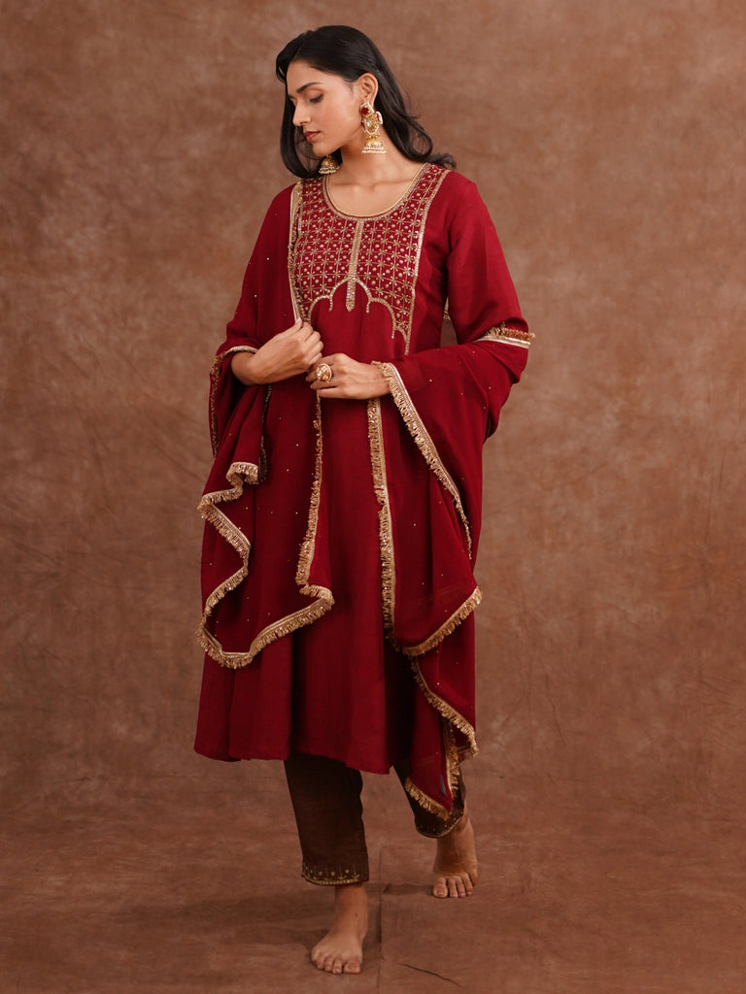
A good handwork kurta set (the ones buyers actually invest in) should be able to handle more than one night out. here’s a simple way to think about versatility without losing that festive vibe.
Daytime festive gatherings
For lunches, pujas, and family visits, choose lighter embroidery in softer tones. Pair with flats, pearl jewellery, and gentle makeup. The handwork brings charm without pushing the look into “too formal”.
Pro Tip: Keep daytime styling minimal. The handcrafted detail is already doing the decorative work.
Evening functions and receptions
For sangeet nights and receptions, you can push contrast. Go for heavier jewellery like Polki, add a sleek updo, and try metallic heels. Doing this turns the same ethnic kurta set into a more polished evening look.
Pro Tip: Change only the accessories, not the outfit. One kurta set can cover two very different events this way.
Weddings and trousseau planning
Handcrafted kurta sets work well for wedding wardrobes, from family dinners to pujas, because they balance festive richness with comfort. For a trousseau, pick a few complementary colours so dupattas and bottoms can be mixed across different pieces, without feeling random.
Pro Tip: Plan trousseau purchases of handcrafted kurta sets for women around a shared palette. Two or three coordinated colours can basically multiply your outfit combinations, quietly but surely.

With Or Without Dupatta : Choosing the Right Set
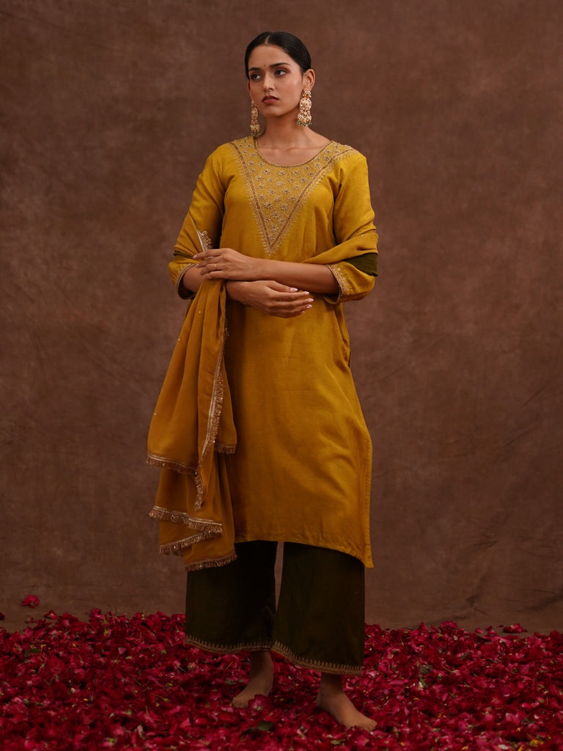
Most handcrafted kurta sets for women actually come in two versions, you know with dupatta and without , and that small change matters more than you think, like how you’ll style it later. If a set includes a dupatta it feels more complete for festivals, weddings , and formal nights , because the dupatta usually has matching handwork on the border. A set without a dupatta gives you room to move, you can team it with a contrasting dupatta you already own, or just wear the kurta as it is for day to day comfort, somehow it just works.
● Choose with dupatta for weddings, pujas, and evening functions.
● Choose without dupatta for office days, travel, and casual meetups.
● If you already have a bunch of simple dupattas, a set without one helps you build more outfits with what you have.
Pro Tip: Check if the dupatta’s handwork matches the kurta too, when the borders look coordinated it feels intentional, not like you just put things together.

Buy Kurtas for Woman Online in India : A Practical Checklist
When you buy kurtas for woman online in India , handcrafted pieces need a bit more attention than basic ones, mainly because the price is higher and the details don’t forgive. So this list is there to help you decide without second guessing later.
● Compare the size chart using your own measurements not just your usual size, and also note if the set is fitted, relaxed, or flared.
● Read the fabric and technique details together, like “cotton-crepe with resham work” , because that tells you how it will feel and how it will hold up.
● Look at every photo carefully, especially closeups of embroidery, back views , and any detail shots of the dupatta.
● Match delivery timelines with your event date, and keep a buffer for alterations.
● Read return and exchange rules before you pay, especially if the item is heavily embellished.
● Check care instructions early, so you’re not stuck later asking whether dry cleaning is needed.
Pro Tip: For a specific event, try ordering at least two weeks before. It gives you space for exchanges and small tailoring without stress.

Understanding Price : What You Pay For in Handcrafted Work
Handcrafted kurtas range a lot, from lightly embroidered cotton sets that are easier on the budget, to silk sets with richer work that can cost several times more. If you understand what pushes the price up, you can judge value instead of just counting numbers.
● Time: More hours of handwork usually means higher cost. Dense zardozi or beadwork can take ages per garment.
● Materials: Silk, better thread, and real metallic detailing cost more than basic alternatives.
● Construction: Lining, finishing, and structured tailoring improve durability, and yes, they add to the cost.
● Set contents: A full set with an embroidered dupatta is often priced higher than a kurta paired with plain bottoms.
A useful way to think about it is cost per wear. A well made piece you rewear across festivals, weddings, and family events can end up cheaper per use than several “cheaper” pieces you wear only once.

Pro Tip: If your budget is tight, spend on one beautifully made festive set rather than multiple lightly decorated ones. You’ll wear it more and remember it longer too.

Fit and Sizing for Embellished Kurta Sets
Embroidered fabric usually has less give than plain cotton, so fit becomes extra important. A handcrafted kurta that is too tight can strain at the seams and put pressure on the embellishment, while one that is too loose can look kind of shapeless and pull attention to the hem.
● Use the size chart for each product, because cut and proportion can shift between styles.
● For Anarkali and flared cuts, check bust and waist measurements carefully, the flare hides less than you think.
● For straight cuts, focus on hip and arm measurements too, especially in more structured fabrics.
● If you’re between sizes, the larger one is often easier to adjust, since tailors can take in more easily than let out.
Pro Tip: Save your measurements on your phone for any. ethnic kurta set It makes online shopping faster and more accurate, basically less guessing.

Caring for Handcrafted Kurta Sets So They Last
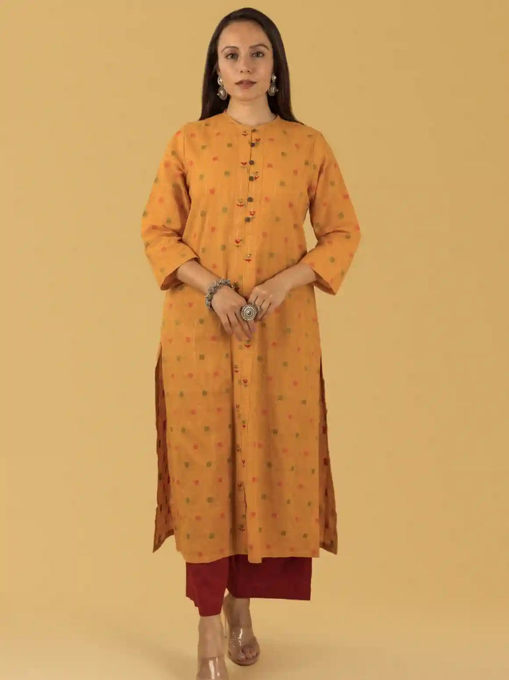
Handwork is a real investment, and how you store and clean it decides whether it stays gorgeous or dulls early. Since these pieces often carry weight from embellishment, they need treatment beyond regular everyday clothes.
● Dry clean heavily embroidered, silk, and zardozi pieces instead of washing at home.
● Store embellished sets in breathable muslin bags, not plastic covers , because plastic can trap moisture.
● Fold heavily worked pieces instead of hanging them, the weight of handwork can stretch the fabric over time.
● Keep away from direct sunlight and strong perfume , to protect thread colour and any metallic shine.
● Air out stored pieces now and then, especially before and after the monsoon season.
Pro Tip: For an ethnic kurta set, place acid free tissue between folds of heavily embroidered areas. It helps stop snagging and keeps the surface smooth.

Common Mistakes When Buying an Ethnic Kurta Set
● Choosing only from photos, without reading fabric and technique details.
● Ignoring how heavy the embroidery is and picking a thin fabric that can’t actually support it.
● Buying only heavily worked pieces and having nothing simpler for everyday festive wear.
● Skipping the size chart just because the model looks like a perfect fit.
● Hanging embroidered pieces for months, which can stretch the shoulder area.
● Overlooking care needs and then being surprised by dry cleaning costs later on.

Pro Tip: Before buying any ethnic kurta set , or handcrafted kurta sets for women, ask yourself three things: Where will I wear this? What will I pair it with? How will I care for it? If you can answer all three , you’re usually buying the right thing.

Frequently Asked Questions
What are Handcrafted kurta sets for women , really?
Handcrafted kurta sets for women are outfits where embroidery, beadwork or other decoration is added and finished by hand, most times using resham, zardozi, mirror work, and similar techniques… you know the idea, it’s not just printed.
How can I tell if an ethnic kurta set is truly hand embroidered?
Check close-up images , for tiny differences in the stitches—like every few areas won’t look perfectly identical. Also, take a look at the back of the embroidery if there’s a photo, and read the technique name in the description. If the listing is vague or the price feels too low, it might not match the hours of work involved.
Which fabric is best for heavy embroidery?
Silk, cotton-crepe, and georgette are often chosen because they can hold dense handwork without strain or tearing. Silk and cotton-crepe feel a bit more structured, so they’re very common for fuller detailing.
Can I wear the same set for day and evening events?
Yes, totally. Wear it in daytime with minimal pearl jewellery, lighter makeup, and flats. Then for evening, switch to heavier Polki jewellery, a neat updo, and metallic heels, so it looks richer and more “set for the moment” kind of vibe.
How should I store hand embroidered kurta sets for woman?
Keep them in breathable muslin bags, fold them instead of hanging, and dry clean when needed. This helps the fabric not get stretched from the added weight of the handwork.

