Ethnic Coord Set for Women: Linen Cotton Co-ord Guide
By Sugandh Gupta | October 22, 2026
There is a reason co ord sets have moved from the edge of Indian wardrobes to the centre of them. They solve this daily puzzle, how to look put together without spending like twenty minutes matching a top a bottom and a dupatta. And once the pieces are designed together, the choice is already made, kinda, for you. An ethnic coord set for women takes that convenience a bit further, with Indian prints embroidery and those silhouettes that feel quietly familiar even when the cut looks more modern.
Also honestly, the category is easier to love than it is to buy. Fabrics vary so much, prints can show up different on screen than in person, and the word “co ord” gets used for everything from a gym set to a festive sharara, so you have to read a bit. This article is for someone who is about to shop and wants to understand the real details: what a good set is made of, how to choose between fabrics like a Linen cotton co-ord set versus silk or georgette, how to size correctly online, and how to style the same outfit in a few different ways without repeating yourself.
Each section ends with a pro tip, so you can grab one practical idea at a time, whether you’re buying your first set, or adding another one to the outfits you already wear on repeat.
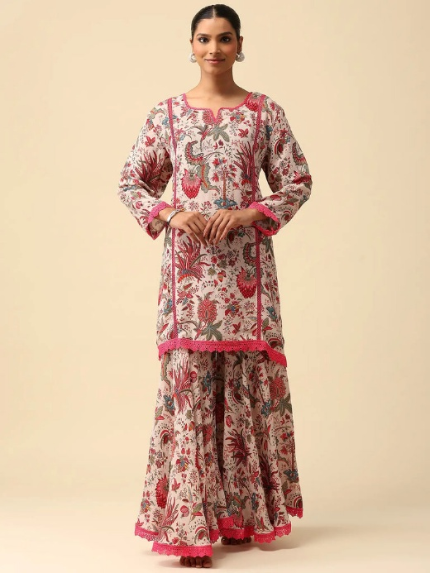
What Is an Ethnic Coord Set for Women, Really?
A co-ord set is basically a top and bottom in the same fabric, designed to be worn together. Now an ethnic coord set for women adds Indian design language: block style prints, floral and botanical patterns, geometric motifs, hand applied embellishment, or a silhouette that nods to a kurta tunic or sharara. It sits right between a kurta set and a western two piece, which is why it works for so many different occasions.
What makes it different from just wearing a matching top and trousers is intention. In a well made set, the fabric weight, the print scale, even the hem and seam finishing are planned across both pieces. The top is cut to fall properly over the bottom, and the bottom is proportioned to balance the top. That’s the kind of difference you notice after you’ve worn it for a full day, not just for a photograph.
It also helps separate the idea from the trend. Co-ords are popular, sure, but the real reason they keep coming back is practical: they reduce styling effort, they pack nicely for travel, and a single purchase can behave like two or three outfits once you wear the pieces separately.
Pro Tip: Before buying, check if the top and bottom look good on their own. A set that you can split into two wearable pieces is usually better value, than one that only works as a pair.

Why a Linen Cotton Co-ord Set Suits Indian Weather
If there is one fabric story worth paying attention to, it is this one. A Linen cotton co-ord set mixes linen’s airy textured coolness with cotton’s softness and easy care. In a country where many months feel warm and humid, this pairing is actually useful, like genuinely.
The fabric breathes, dries quickly, and stays comfortable against the skin during a long day of commuting, work, travelling, or those “I’m just running errands” errands that somehow become a whole outing.
Texture and drape
Linen leaning fabrics have that natural slightly crisp texture, so the outfit looks relaxed but also a little tailored. A good Linen cotton co-ord set holds its shape without looking stiff, and the soft slub in the weave makes it feel intentional even when it’s lightly creased.
Comfort through the day
Because air can move through the fabric, it tends to feel lighter than many synthetics and it doesn’t cling in humid conditions. That’s why linen style co-ords often end up being the go to for daytime brunches, college days, short trips, and relaxed office schedules.
What to look for in the product description
Look for the fabric to be named clearly. On sugandh.co, linen shows up in product names for some co-ord sets like the Gulraas linen series, and the collection page also talks about cotton crepe for everyday wear. Still, read the specific listing for composition, because “linen look” and true linen are not the same thing.
Pro Tip: When it arrives, press the fabric lightly in your hand. Linen cotton should crease a little and then bounce back; if it feels slippery and looks shiny, it’s probably a synthetic imitation.

Fabric Guide: Cotton-Crepe, Silk, Georgette and Linen
Choosing the fabric matters more than choosing the colour, because it shapes comfort, occasion, and how long the outfit stays wearable. Here’s how the main options usually behave in an ethnic coord set for women.
Cotton-crepe for everyday and office wear
Cotton crepe is soft with a slight texture, and it’s resistant to creasing, so it’s practical for work and daily wear. It holds its shape through meetings and commutes, and usually needs very little fuss.
Silk for festive occasions
Silk co-ords are the dressier option. They have a natural sheen, and they feel luxurious even with simple jewellery. That makes them a good pick for Diwali evenings, family functions, and pre-wedding events.
Georgette for sangeet and evening events
Georgette is light and flows well, so it moves beautifully when you dance. It pairs nicely with statement earrings and embellished heels, and it suits shararas and flared bottoms especially well.
Linen for relaxed daytime elegance
Linen and linen cotton are best for warm days, casual outings, and travel. They feel natural, understated, and they go easily with minimal jewellery and flat footwear.
Pro Tip: Match fabric to occasion first, then match it to colour after. Cotton crepe for office, linen for casual days, and silk or georgette for celebrations.

Ethnic Co Ords Set Styles: Prints, Embroidery and Silhouettes
The phrase “Ethnic Co Ords Set” covers this surprisingly wide set of looks. The easiest way to narrow it down is to figure out what kind of detailing you actually want to wear.
Floral and botanical prints
Floral prints are that evergreen choice. Botanical designs in blue, pink, and orange feel fresh and cheerful, and they work for daytime outings as well as festive lunches, like both without looking too much.
Geometric, abstract, and striped patterns
Honestly, geometric and abstract patterns feel kinda more contemporary , and they fit office days plus travel quite well. Stripes kinda give you that longer look, and the whole thing feels polished even with just a simple belt, or tidy footwear.
Embroidered co-ords
When embroidery is hand-applied it can lift a co-ord from “everyday” to like, occasion-ready, without going overboard. Usually a little detailing at the neckline , hem or cuffs is enough. You do not need heavy work for the outfit to look special, it’s more about the placement.
Sharara and loose-fit silhouettes
Beyond the usual top and trousers, you’ll also spot sharara sets, tie-detail tops, and that loose-fit vibe. Sharara sets add a festive kind of swing, while loose-fit sets really focus on comfort first , and style second (but still cute).
Pro Tip: If you are unsure about prints, start with a solid colour or a subtle small-scale pattern, it’s just easier to repeat , and easier to style different ways too.
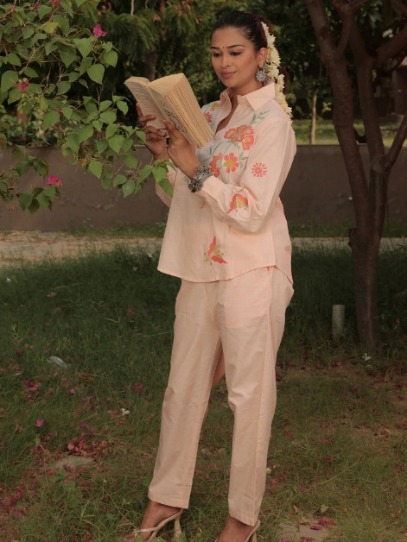
Buy Stylish Embroidered Co Ord Set Online at Best Price: How to Decide
When you Buy Stylish Embroidered Co Ord Set Online at Best Price, the price should be read along with quality. A lower price can be amazing if it’s tied to a sale or efficient production, but it’s also a small warning sign when the fabric, stitching, and finishing are not even mentioned properly. So check what the listing says about fabric, embroidery type, lining, and care.
Also , embroidery quality is worth looking at properly. Zoom into the photos and check how even the stitching looks, whether motifs line up at seams, and if the edges look finished. If embroidery is placed over something thin , make sure the base fabric can handle it without puckering.
It also helps to compare the original price with the sale price. Many sets on sugandh.co sit around Rs. 1,500 to Rs. 3,600, and discounts are listed from the original price, so you get a clearer sense of the usual range for an everyday yet festive co-ord that’s made well.
Pro Tip: Save 2 or 3 product links so you can compare them side by side. Don’t just stare at the final price—check fabric, embroidery, the size range , and exchange policy too.

Occasion Guide: Where to Wear an Ethnic Coord Set for Women
One reason an ethnic coord set for women is so useful is the variety. If you use it thoughtfully, it can pretty much cover a big part of your week, without effort.
Office and meetings
Go for cotton-crepe or linen cotton in muted tones like beige , grey, blue and white. A structured top with neat trousers looks professional, and the set works really well with loafers or flats.
Brunches, college and casual outings
For these days, prints and brighter colours usually behave better. Pair them with sneakers or comfortable sandals, then add a tote bag, and you get that effortless, put-together look.
Festive days and family functions
Try silk or embroidered co-ords with jhumkas and a potli, it feels festive without the extra weight of a lehenga. A matching dupatta is optional, but it’s honestly such a nice add-on.
Sangeet and evening events
Georgette shararas or flowy sets plus embellished footwear are ideal. They help you dance, and move around, without managing layers of fabric every two minutes.
Travel
Co-ords are honestly one of the best travel choices because they pack well, resist heavy wrinkling (when the fabric is chosen right), and can be worn in different combinations.
Pro Tip: Make a capsule of three co-ords—choose a Linen cotton co-ord set as your neutral base, add one printed set and one festive one, and you can cover work, weekends, and family events without overpacking.

Buy Co-ord Sets for Woman: A Step-by-Step Online Buying Checklist
Whenever you Buy Co-ord Sets for Woman online, some quick checks reduce the chance of disappointment. First look at all photographs, including detail shots and the back view. Second, read the fabric section and the care instructions. Third , match the size chart with your own measurements. Fourth, confirm delivery times if you need it by a specific date. Fifth , read the exchange policy before checkout.
On the collection page at sugandh.co, you can filter by availability, price, size, colour and category, then sort by best selling or price. With 23 pieces in the collection, filters make everything narrower fast. The page also mentions complimentary delivery across India and an exchange policy, but it’s smart to confirm at checkout too.
Pro Tip: Use the colour filter with the “match-all” option to find sets that fit the palette you already own.
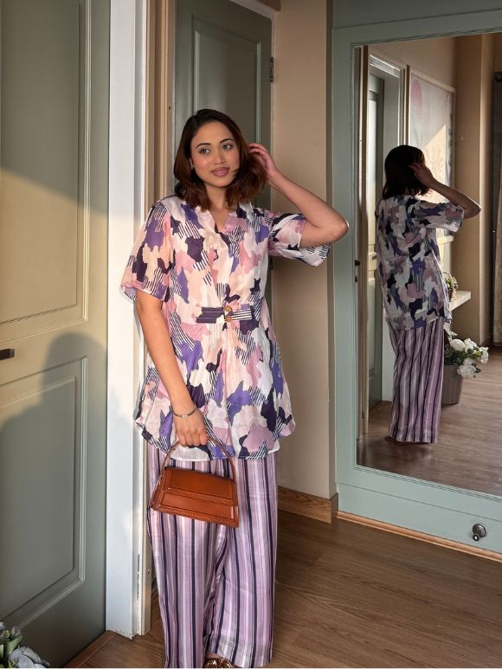
Co-Ord Sets for Woman Online India: Sizing, Fit and Alterations
Sizing is the biggest cause of returns when you shop Co-Ord Sets for Woman Online India. The size filter on the collection shows S to 2XL, but the page text says XS to XXL, so always check the size chart on the specific product.
Measure your bust, waist, hips, and if you can, measure the length from shoulder to your preferred top length. For loose-fit sets, you usually have more flexibility. For fitted tops and trousers, pick the size that fits your widest measurement, then adjust the rest if needed.
A good tailor can shorten a hem, take in a waist, or adjust sleeve length pretty quickly. For occasion wear, even a small alteration can make the fit look custom-made, not just “online bought.”
Pro Tip: Keep a note on your phone with your measurements and your best-fitting size for each brand. This makes future online orders faster , and way safer.

Colour choices that work across skin tones and seasons, kinda and sorta
On sugandh.co the co-ord collection usually sticks to blue orange grey green pink purple red and white, plus a few multicolour options and also beige , sometimes. Blue is the most popular, and honestly it works: it feels fresh in summer, looks sharp in the office, and it can feel calm in the evening too.
If you lean warm , tones like orange yellow and marigold usually suit festive moments, and they often look amazing in daylight. Cooler shades such as teal lilac and mauve give a more elegant vibe, especially at night. For the easiest mix and match , neutrals like beige and white are the safest bet—also they’re a solid starter for almost any capsule wardrobe
Quick test, try this : hold the fabric close to your face in natural light. If your skin looks brighter and more even, then that shade is a good pick. A linen cotton co-ord set in a soft earthy tone, for instance, tends to flatter lots of different complexions
Pro Tip: For a Linen cotton co-ord set, choose a colour you already have accessories for. First wear becomes effortless , and you end up repeating the outfit more often, which is the whole point
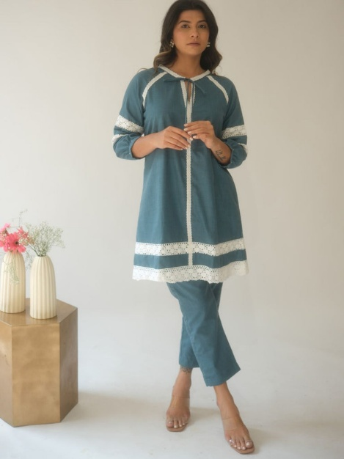
Styling an ethnic coord set for women, accessories and footwear-ish
The nice part about an ethnic coord set for women is that small changes can turn it into totally different looks. With flats and light jewellery, it feels relaxed and day appropriate. Switch to heels, add statement earrings and a potli, and the same outfit becomes an evening option
Jewellery
For printed sets, keep it simple: small earrings or a delicate chain, nothing too busy. For solid colours, go bolder with jhumkas or layered necklaces, so it doesn’t look plain. Georgette sets usually look really good with statement earrings and minimal neckwear
Footwear and bags
Juttis, flats and even sneakers work for casual days. If you want it dressed up , block heels and embellished sandals do the trick. For work , a structured tote looks neat, and for evenings a small clutch is usually perfect
Layering
Add a lightweight jacket, shrug, or a dupatta and the whole mood changes fast. A longer shrug can read Indo-fusion , while a plain dupatta in a contrast shade makes a casual set feel more festive
Pro Tip: Style the same set three ways: office, brunch, and evening. If you cannot picture all three, you might not wear it enough

Wearing the pieces separately, getting more out of every set kinda
Yes, the set is made to be worn together, but the pieces can also be separated often. In the brand’s FAQ it says tops and bottoms can be styled apart, even though the set is designed as one full outfit. That’s basically where the real value shows up
A printed top can work with plain white trousers or jeans, and plain trousers can pair with a different kurta. If you have a solid top from a linen set, tuck it into a skirt and it becomes an easy weekend look. The more neutral the pieces are, the more combinations you can build
Pro Tip: Before you cut tags, test each piece with things you already own. If both pieces work separately, then the set is worth buying

Caring for Linen cotton, cotton-crepe, silk and georgette sets (because it matters)
How you care for it affects how long it still looks fresh. For cotton-crepe and linen, the brand recommends dry cleaning, or a gentle cold hand wash. Dry it in shade , and iron on a low to medium setting while the fabric is still slightly damp
Silk and georgette are more delicate. For embellished pieces, dry cleaning is usually the safest route. Store the sets folded inside breathable cotton bags, not plastic. Also avoid hanging heavy pieces for long periods. Keep perfume and hairspray away from the fabric too
A linen cotton co-ord set typically softens with each wash, and yeah many people love that feel. Don’t stress small creases, they’re kinda part of linen’s charm
Pro Tip: Wash a new linen cotton co-ord set separately the first time, in cold water, so colour transfer doesn’t sneak in

Common mistakes when choosing co-ord sets
First mistake, ignoring fabric. A beautiful print on thin, clingy fabric might not feel comfortable in warm weather. Second mistake, skipping the size chart. A loose fit may forgive you, but a fitted one usually won’t. Third mistake, forgetting occasion, like wearing a heavy silk set to a daytime casual meeting
Another common slip is buying very trendy prints that might feel outdated by next season. Classic florals, solids and simple geometrics tend to last longer. And finally, many people forget to check if the pieces can be worn separately, so they miss the easiest extra outfit options
Pro Tip: Before buying any ethnic co ord set, ask yourself: Where will I wear it first? What will I pair it with? Will it work separately? If you get clear answers, it’s usually a better purchase

Frequently Asked Questions
What is an ethnic coord set for women?
An ethnic coord set for women is a matching top and bottom made together, featuring Indian prints embroidery or silhouettes—from tunics with trousers to sharara sets
Is a linen cotton co-ord set good for summer?
Yes. A linen cotton co-ord set is breathable, light, and dries quickly, so it stays comfortable in warm and humid weather
Can I wear a co-ord set to the office?
Absolutely. Cotton-crepe or linen-cotton sets in muted colours are great for office wear, because they hold their shape and resist creasing
How do I buy co-ord sets for woman online in India safely?
Check the fabric description, match the size chart to your measurements, look at all product photos, and confirm the exchange policy before you place the order
Can I wear the top and bottom separately?
Yes, many sets can be worn as separate pieces and mixed with other items from your wardrobe

