Best Indowestern Dress for Women: Indo Western Guide
By Sugandh Gupta | October 22, 2026
Walk into wedding season and you will see this little shift, in the room, like almost quietly. Next to the usual lehengas and sarees more women step in wearing shapes that dont really sit in either camp, like a cape draped over a pre-draped skirt, a kaftan with zari lines, a kurta set with that asymmetric edge, or a gown with Indian embroidery on a western sort of cut. That whole zone is fusion dressing, and finding the Best Indowestern dress for women is one of those questions that keeps coming up in searches, because everyone wants that sweet spot.
And honestly it makes sense. Traditional outfits can feel heavy for that long multi-event week, while full western dresses sometimes feel a bit off at a family function, you know ? Indo western pieces sit right in the middle. You still get the colours, the craft and the modesty that Indian events expect , but the way it moves, drapes and even photographs feels lighter, more current. That balance is why Indo western for marriage is no longer just a niche thing, it is now a mainstream option for guests, cousins, sisters and even brides during their own pre wedding moments.
This is a practical read, more like for someone who is actually going to buy. It breaks down what fusion wear really is (not just the vibe), what types exist, how to choose by occasion, fabric and body shape, how to shop online without ending up with regret, and how to care for what you purchase. Each section also ends with a pro tip, so you can take one usable idea, and go.
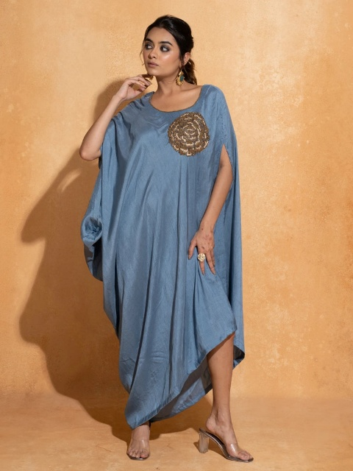
What Makes the Best Indowestern Dress Different from Ordinary Fusion Wear
Not everything that says “fusion” is automatically the real deal. The Best Indowestern dress is not just an Indian outfit with a western zip added, or a western gown with a token border slapped on, basically. It’s a piece where the two traditions are balanced on purpose. The cut may borrow western tailoring, like a structured collar, a fitted bodice, a cape, or a sharper shoulder line, but the surface still carries Indian craft embroidery, mirror work, zari, block prints or those hand-finished borders.
A simple way to judge it is to ask, what would disappear if you removed one side. If you take out the Indian detailing and the outfit is suddenly just a plain western dress , then the fusion was mostly cosmetic. If you remove the western construction and it turns into a regular kurta, then it’s the same story. When both halves are doing real work, it feels designed not “assembled”. And that is what keeps it from being only a one-season trend.
It also helps to remember that fashionable Indo western dresses are meant to solve a problem. They are for the woman who wants to move comfortably, sit through long rituals, dance at the sangeet, and still look put together in photos. Comfort, mobility, and visual impact all matter, and the pieces that handle all three are the ones people keep asking about.
Pro Tip: Before you buy the Best Indowestern dress, describe it in just one sentence, like what is Indian about it and what is western about it? If you can answer both, clearly, then you are looking at real fusion and not a costume.

The Main Types of Indo Western Dresses for Woman Explained
Browsing Indo western dresses for woman can feel a lot because the category covers so many shapes. It helps to group them by what they do best. The collection on sugandh.co, for instance, is built mostly around kurta sets and kaftans, with dresses, anarkalis, an angarkha gown, a gown, and a lehenga rounding it out. That matches how most shoppers actually build their fusion wardrobe.
Fusion kurta sets
Kurta set is the easiest entry point. Think asymmetric hemlines, structured collars, western-inspired sleeves, and trousers or skirts instead of the classic churidar look. It reads ethnic first, but then it feels fresh right after. If you want one outfit that can handle a daytime ceremony and still look good for an evening dinner, a fusion kurta set is usually the safest and most flexible choice.
Kaftans
Kaftans are comfort superstars. Their relaxed shape works great in warm weather, destination weddings, and those long days when you do not want anything clinging. And when they have embroidery, cut work or zari, they dress up easily with way less accessorising. Another underrated plus: they forgive small fit changes, which is a real advantage during those wedding buffet days.
Dresses and gowns
Fusion dresses and gowns usually come in floor-length or midi silhouettes with embroidery, appliqué, or Indian textiles built into a couture-style structure. They fit receptions and cocktail evenings where a regular lehenga might feel too much, but a normal party dress feels like too little.
Anarkalis, angarkhas and lehengas with a twist
A fusion anarkali can add a cape or a cowl. An angarkha gown reworks that classical overlapping front into a modern floor-length shape. And a fusion lehenga can pair a structured blouse with a less usual drape or a more modern dupatta treatment. These are the options to check when the occasion is clearly festive, but you still want something different from everyone else in the same room.
Pro Tip: When you hunt for the Best Indowestern dress, begin with one versatile piece, usually a kurta set or a kaftan, then only later think about a statement gown. A versatile piece basically earns back the cost because you will repeat-wear it.

Indo Western for Marriage: Picking outfits like it’s an actual event
Marriage celebrations are kinda a bundle of moments, and the correct fusion outfit just… changes with each one. Honestly the biggest reason people feel underdressed or overdressed is because they try to treat everything like it’s one “wedding outfit” problem. So, instead, think about Indo western for marriage event by event, it makes life so much easier, even if you’re rushing.
Haldi and mehendi
These are daytime, more casual , usually outdoors and yes sometimes messy. So go for bright but breathable choices, yellows , oranges , greens, and pinks in lighter fabric. A relaxed kaftan or even a short fusion kurta set works well because you can sit down, pose for pictures, and not worry about a long hem doing drama. Also try to choose something you won’t mind seeing a bit of turmeric on , because… it happens.
Sangeet and cocktail
This is the part where fusion outfit really gets to shine. A fluid cape set , a gown with embroidery, or a structured fusion dress lets you dance, mingle and sit without fighting layers of fabric the whole time. Look for movement, georgette and chiffon swirl nicely under lights, while satin gives a more polished glow and it photographs super well too.
The wedding ceremony and reception
For the main ceremony, family expectations often feel more serious, so go for fuller coverage, richer colours and craft that shows. Think silk fusion kurta set, or an embroidered gown in deeper tones like wine, bronze, or deep red. Then for the reception, you get more space to be bold with your silhouette, without feeling like you’ll “break” a vibe.
As a bride’s sister or close family
If you’re going to be in family photos for hours, choose something festive and coordinated, but not competing with the bride. Jewel shades and mid-tones usually land well, and a polished fusion look often shows up more elegantly in photos than a very heavy outfit that makes moving awkward.
Pro Tip: Make a tiny timeline of every event you’re attending, then assign one outfit and one colour family to each. This helps you avoid double buying, and Indo western for marriage shopping feels… way calmer.

Fashionable Indo Western Dresses: What people keep repeating right now
Trends matter less than fit and quality, but still, knowing what’s currently popular helps you pick pieces that won’t feel random next year. A few ideas keep coming back in fashionable Indo western dresses for festive wear.
Capes, cowls and pre-draped silhouettes
Attached capes and cowl necklines create a dramatic look without the stress of managing a loose dupatta. Pre-draped skirts do a similar thing for the lower half, giving drape vibes while staying stitched and practical. People love these because they solve the very real issue of keeping a dupatta in place through an entire evening.
Asymmetry and strong lines
Uneven hemlines, diagonal closures, and crisp collars bring a tailored, modern feel to ethnic fabrics. These details look current, but they don’t date quickly, especially when the colour and fabric feel classic.
Colour stories
In the Indo western collection on sugandh.co, reds , oranges , blues , bronzes, and pinks show up a lot, with smaller options in beige, black, green, and yellow. That matches what many shoppers want: warm festive shades for celebrations, plus neutrals or darker tones for evening events. Warm saturated shades usually photograph beautifully in daylight, and deeper shades feel naturally elegant at night.
Pro Tip: For Indo western for marriage, treat trend elements like a single note, not the whole song. If your outfit already has a cape , keep the jewellery and makeup calmer instead of adding more statement things.

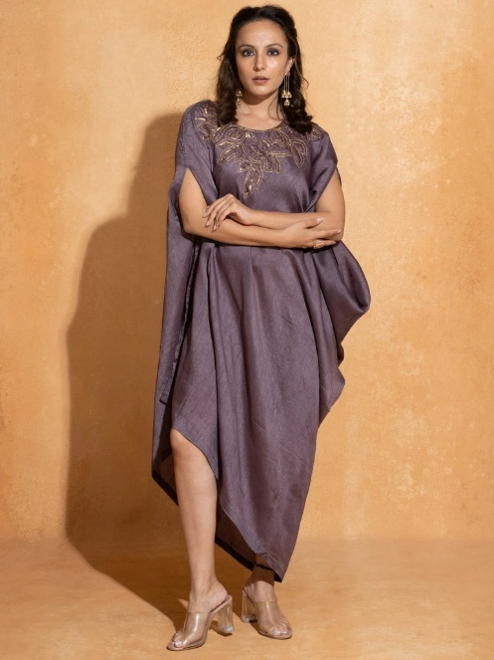
Fabrics That Carry a Fusion Outfit Well
Fabric decides if the outfit looks expensive or a little flimsy, comfortable or restrictive. And it’s honestly the most ignored factor when people only focus on the photo. For a Best Indowestern dress, choose the fabric based on where and when you’ll wear it, not only the look.
Silk and satin for structure
Silk brings richness and holds embroidery really well, so it’s great for structured bases, formal ceremonies, and cooler weather. Satin gives a smooth, polished surface that works for evening wear, but it can show creases, so it needs careful steaming.
Georgette and chiffon for movement
Fluid georgette and lightweight chiffon are the go-to choices for capes, cowls and overlays because they float. They’re comfy in warm weather and usually flatter different body types since they skim rather than cling.
Reading the fabric label
Always check the fabric description on the product page. If a listing doesn’t mention fabric at all, treat that as a warning and ask before you buy. Brands that truly care usually name the material.
Pro Tip: When your Best Indowestern dress arrives, rub a small corner of the fabric between your fingers. Good silk and georgette feel smooth and cool, not scratchy or plasticky, and they should not leave any rough residue.

Dress Woman Indo Western: Matching silhouettes to body shape
The phrase Dress Woman Indo Western gets searched by shoppers looking for fit guidance more than trend talk, and honestly that’s where fusion wear either wins or loses. These are guidelines, not strict rules. The most flattering outfit is still the one you feel comfortable in, no matter what anyone says.
If you want to define your waist
For a Dress Woman Indo Western look that defines the waist, pick pieces with structured bodice, a waist seam, or a belted element. Cape sets with a fitted inner layer , and fusion gowns with a defined waist, create shape without feeling tight.
If you prefer a relaxed fit
Kaftans and flowing dresses are naturally forgiving. A subtle V-neckline and vertical embroidery lines can add length. Border detail near the hem also pulls the eye downward in a pretty, elegant way.
If you are petite
Try not to overload with too much volume. Choose shorter capes, clean vertical lines, and slightly high-waisted silhouettes. Also keep the print scale smaller, and try to keep the colour tone consistent from top to bottom, so it doesn’t break you up visually.

If you are tall, Floor-length gowns with wide skirts and those layered cape things can work really well because you can carry the extra volume gracefully. also, strong horizontal details , like bold borders , tend to look balanced not like they’re shortening you or anything.
Pro Tip: When picking the best indo western dress for your shape, try it on and then do all that stuff, sit, bend, lift your arms, take a few steps. If the cut feels good only when you’re standing super still, chances are it won’t handle a real event.

Colours and Palettes for Different Seasons and Times of Day
Colour impacts comfort and photographs, so it’s not just about looks. bright shades and soft pastels are usually great for sunlit day events, while deeper jewel tones and a little metallic sparkle can look more natural when it’s evening, or under darker lighting. matching your colour to the time of day is honestly a fast move, you look appropriate without overthinking it.
For indo western for marriage in winter , deeper tones like wine, bottle green, bronze and navy feel rich and kind of luxurious. In summer weddings, lighter palettes such as peach, orange, sky blue, soft pink, they feel fresher and lighter. If you’re unsure though, red is a safe traditional choice because it suits most settings and most skin tones too.
Also, when choosing a colour, hold the garment near your face in natural light. The right shade makes your skin look even and brighter, the wrong shade can make you look a bit tired. it’s a simple trick, saves a lot of returns, really.
Pro Tip: Build around one signature colour that suits you, then repeat it in small ways across the events with accessories, so your whole wardrobe feels connected, not random.

Accessories, Footwear and Styling the Complete Look
A fusion outfit gives more flexibility than fully traditional looks, which is kind of freedom but also a tiny risk. the idea is simple though: let the garment be the main character, and keep accessories as support, not the loudest thing in the room.
Jewellery
If the outfit is heavily embroidered, go for simple earrings or one statement necklace, not both together. For plainer silhouettes, you can wear bolder jhumkas, a choker, or layered necklaces. oxidised and kundan jewellery also works nicely with fusion cuts. And pearls? they add a quietly elegant finishing vibe.
Footwear
Block heels and wedges are more comfortable for long events. embellished flats can suit daytime ceremonies. If your hem is long, choose shoes you can actually move in; nobody really remembers the heel height, but everyone remembers the limp.
Bags, hair and makeup
A small potli or structured clutch usually fits best. For hair, sleek buns, soft waves, or a side-swept style pair well with structured collars and capes, while a loose braid looks better with kaftans. makeup should match the formality, keep either eyes or lips as the focus but not both, otherwise it can get too busy.
Pro Tip: For any indo western for marriage event , lay out the complete look already, like jewellery, shoes, bag, the whole thing, before the event. If anything feels like it is competing with the outfit , remove it.
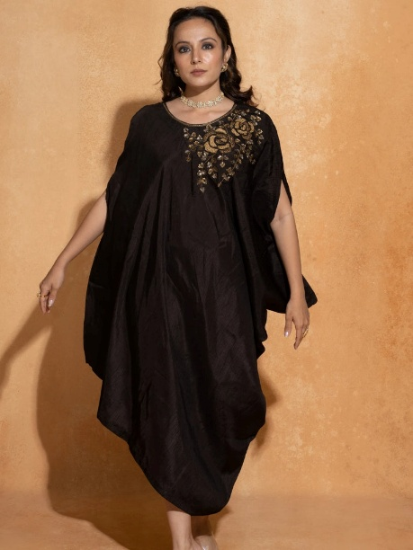
Indo Western vs Traditional Outfits at Weddings
It’s fair to wonder when fusion makes sense and when traditional is the better call. mostly it depends on the audience and the ritual. for core ceremonies where expectations are strong, a traditional outfit is usually safer , or a fusion piece that still has strong traditional cues. For pre-wedding events, receptions, cocktail nights, or destination celebrations, fusion tends to feel more comfortable and more expressive.
There’s also a practical side. a well picked fusion outfit often gets restyled easier. A fusion kurta set can be reused with different trousers, a kaftan can be belted to feel new, and a cape can often work with a plain skirt. So indo western for marriage can be more budget-friendly over time, compared to one-time heavy outfits.
Pro Tip: If you’re attending a conservative family wedding, choose a fusion piece with full sleeves, modest coverage, and traditional embroidery. you’ll blend in respectfully and still look modern.

Buy Indo Western Dresses For Woman Online in India: A Smart Checklist
Shopping online gives way more choice than any single store, but it needs a bit more attention. When you Buy Indo Western Dresses For Woman Online , use a checklist before you pay, just to be safe.
First, look closely at every product photo, especially ones that show details and the back. Second, read the fabric, lining, and measurement info. Third, compare the size chart with your own measurements, don’t just guess. Fourth, confirm the delivery timeline, particularly if you’re shopping for a fixed date. Fifth, read the return and exchange policy before ordering. these five steps take like ten minutes and remove most of the risk.
The indo western collection on sugandh.co can be filtered by availability, price, size, colour and category. It can also be sorted by best selling or by price, which makes it easier to narrow down 35 pieces into a small group that actually fits your budget and event. using filters the right way is basically one of the biggest benefits of shopping online.
Pro Tip: Order indo western for marriage outfits at least two weeks before the event. that gives room for exchange, alterations, or a backup if something does not fit properly.

Understanding Price: What You Are Paying For, basically
Fusion pieces can be really all over the map when it comes to price. In this collection, you’ll see prices starting around Rs. 1,560 for lighter dresses, then jumping to about Rs. 16,999 for heavily crafted kurta sets, and yeah, quite a few items are on sale too. The reason it spreads so much is actually pretty simple once you spot what’s doing the work behind the scenes.
Fabric matters, embroidery density matters, hand work matters, lining and construction complexity too—like, all of it adds up. A plain dress in a light fabric costs less than a silk kurta set with detailed handwork, because the second one needs many more hours of skilled labour, not just “more material”. A higher price isnt always “better”, but if something is priced very low while looking elaborate, then it’s worth checking a bit closer before you assume it’s a steal.
One easy approach is to think in cost per wear. For example, a Rs. 14,000 kurta set worn six times is way cheaper per use than a Rs. 4,000 outfit worn just once. If you’re planning to buy one Best Indowestern dress and wear it again and again with slightly different styling, spending a little more can honestly be the smarter option, not the pricey mistake.
Pro Tip: Decide a budget per event, for your Best Indowestern dress, then decide where you want to splurge. Usually one good “hero” piece plus two simpler outfits, looks better than three outfits that are only mid-level quality.

Fit, Sizing and Alterations, sigh
Sizing is where most online disappointments kick in. The listing shows sizes from S to 2XL, plus some free-size pieces. But because the page wording sometimes feels broader, you should stick to the size chart for the exact piece you want, not rely on the general description.
Take your bust, waist, hips and shoulder width measurements. For free-size pieces like kaftans, look at the chest and length measurements they actually list, so you know you’ll be comfortable. If you land between sizes, pick the larger one for structured pieces. It’s far easier to take something in, than to let it out.
If you can, fit it like a small plan, take a quick visit to a trusted tailor before big days. Little changes to sleeve length, hem, or waist, can take a good outfit to one that looks custom made, no question.
Pro Tip: Save your measurements on your phone, plus your best-fitting size in each style. That way every future online purchase feels faster, and less annoying to get right.

Caring for Your Fusion Outfits, don’t skip this part
Fusion outfits usually mix delicate fabrics with embroidery, so the care routine really counts. First, follow whatever the care label says, full stop. Silk, satin and embroidered pieces are often safer dry cleaned, and lighter georgette pieces can sometimes be hand washed using a gentle detergent.
When you store them, fold them neatly in breathable cotton or muslin garment bags, not plastic. And try not to hang heavy embroidered pieces for long periods, since that can stretch out the shoulders. For smoothing, steam is usually better than ironing directly over embroidery. Also keep perfume and hairspray away from the fabric, because they can leave stains, even when you think “it’s just a little”.
Pro Tip: After each wear, let the outfit air out for a few hours before you pack it away. That helps with trapped moisture, and those unwanted odours, plus your colours stay looking fresh.

Frequently Asked Questions, quick answers
What is the Best Indowestern dress for a wedding guest?
The Best Indowestern dress for a wedding guest is usually a fusion kurta set or a cape set, often in silk or georgette. It brings festive richness, gives you easy movement, and still covers enough for family functions.
Is Indo western for marriage suitable for the main ceremony?
Yes, if you go with the right coverage, rich colours, and traditional craft that actually shows. For more conservative gatherings, choose full sleeves, plus a longer hemline.
How do I buy Indo western dresses for woman online without sizing mistakes?
Use the size chart for the exact style you’re buying, compare it with your measurements, check the fabric details carefully, and read the exchange policy before you order.
Which fabrics are best for fashionable Indo western dresses?
Silk and satin usually give structure and a richer feel, while georgette and chiffon add movement and comfort. The best pick depends on the season, and also the event.
Can I wear the same fusion outfit more than once?
Absolutely. Fusion pieces are easy to re-style with different jewellery, footwear or layering, so it becomes more of a long-term investment rather than a one-time look.

